ChatBot architecture

Typical chatbot architecture

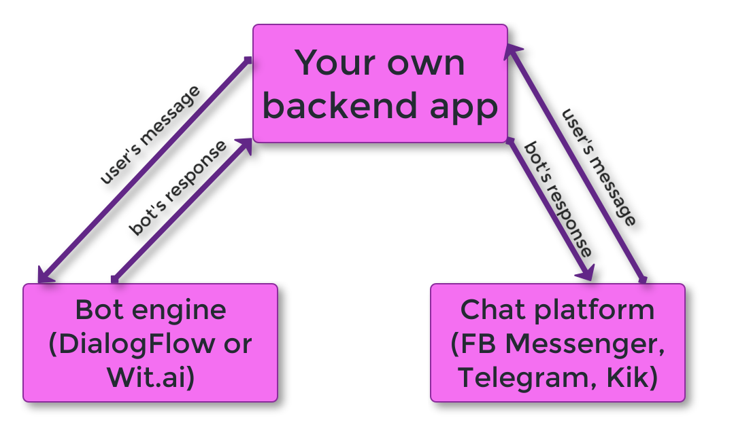

Simple chatbot architecture with DialogFlow

